# Block 2 challenges

## Challenge 1 – Fun Translation

### Purpose

A mobile web application that allows you to translate any message into many different fun languages, and save your favorites to local storage.

### Audience

Want to say something like Yoda? Or maybe say something in Klingon? This app is for you.

### Data sources

* Fun Translations API to get the translations
* Local storage to save favorited translations

### Initial Module List

Model, View, and controller. And a saved translations module.

### Wireframes

A simple drop-down box to select the language, and a text input box to enter the desired translated message, followed by a submit button. After there will be a text box to display the translated message with a save button. After there will be a scrollable list view of the saved translations. The basic view of the list will be as follows, with a trash can in the square.

When an item on the list view is selected a new view will appear with the entire message and view available.

### Schedule

Week 1 – Implement the wireframe of the project including all files and allow for translations to be made.

Week 2 – Implement the saving and deleting to local storage, the list view and the styles.

## Challenge 2 – Mastermind game

### Purpose

A fun brain teasing game.

### Audience

Those that like sudoku or crossword games might like this fun brain game.

### Data sources

Local storage to save current game state and past settings.

### Initial Module List

Model, View, Controller, game state modules.

### Wireframes

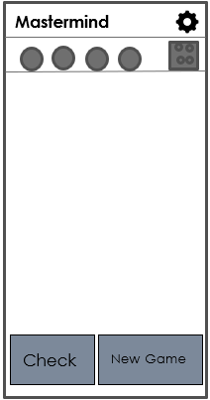

The game will look very roughly like the wireframe on the left. The user will be trying to guess the randomly generated pattern of colors. The amount of possible colors and guesses will be determined by the user, the game board will have to dynamically change based on those settings. Each row with the circles will be a guess, the borders will highlight when it is that guesses turn. Each of the circles within the guess will change color with a tap, once the user is satisfied with the guess, they press the check button. The four circles in the square will either stay the same, change to black or change to white, depending on their guess. For each black circle there is a correct color in the correct spot, for each white circle there is a correct color in the wrong spot, any circle without change means there are that many completely wrong choices. A winning animation is played when the pattern is guessed correctly and a losing animation is played when all guesses have expired.



The setting menu will look similar to this. There will be a drop-down menu for each selection.

**Settings**

**# of colors**

**# of guesses**

Rules: Rule rules rule rules rule. Rule rules rule rules rule. Rule rules rule rules rule. Rule rules rule rules rule. Rule rules rule rules rule. Rule rules rule rules rule. Rule rules rule rules rule. Rule rules rule rules rule.

**Default**

**Save**

### Schedule

Week 3 – Get the main page to display as well as the settings box. Get the settings to update the game board properly.

Week 4 – Implement all game mechanics and changing of colors.